TRAIN BOOKING MANAGEMENT SYSTEM

INTRODUCTION:
The Train Booking System is a versatile and user-friendly web application designed to streamline the process of searching, booking, and managing train tickets online. Suitable for daily commuters, travelers, and administrators, it offers a wide range of features including real-time seat availability, secure ticket booking, PNR status tracking, and booking cancellations — all accessible through a clean and responsive interface. Users can fully interact with the platform using role-based access, while robust security features like JWT authentication, encrypted passwords, and middleware protection help maintain data integrity. The Train Booking System also integrates seamlessly with MongoDB to automate data persistence and real-time updates. With built-in booking management tools, users can track their journey details and export booking history for reference. Its flexibility, ease of use, and powerful features make it an ideal choice for students, commuters, event travelers, and transport administrators seeking an efficient ticket management solution.
SCENARIO Based Case Study:
Meet Ravi, a frequent train traveler with a demanding schedule who values efficiency and organization in his daily commute. Ravi is responsible for managing his own travel bookings across multiple routes and cities, which requires him to stay updated on train schedules, seat availability, and booking statuses.
Ravi discovers the Train Booking System, a comprehensive web application designed to streamline train ticket operations. Intrigued by its features, Ravi decides to explore how the system can help him enhance his travel experience.
User Registration and Authentication: Ravi registers an account on the Train Booking System, providing his personal details and preferences. He logs in securely using his credentials, ensuring that his data remains private and protected with JWT-based session management.
Train Search System: Ravi explores the system's train search functionality, which allows him to input a Source, Destination, and Date to find matching trains. He can easily access real-time seat availability and fare information to plan his journey efficiently.
Customer Relationship Management (Booking Dashboard): The system offers a personal dashboard that allows Ravi to manage all his bookings. He can view active tickets, track booking history, and cancel reservations when plans change.
PNR Status Tracking: The Train Booking System provides Ravi with a dedicated PNR Status Checker. He can enter his unique 10-character PNR number and instantly view journey details, passenger name, and live ticket status — even without logging in.
Order Management (Booking Engine): Ravi can book train tickets directly through the system, with the platform automatically handling seat deduction, PNR generation, and confirmation — ensuring a smooth and error-free booking process.
Training and Support: The system is designed with a simple, intuitive UI backed by toast notifications and real-time feedback. Ravi can navigate the platform easily without requiring any technical assistance.
Ravi's Experience: Thanks to the Train Booking System, Ravi can now manage his travel bookings more efficiently and effectively. He can focus on his journey while the platform handles ticket availability, confirmations, and cancellations. The Train Booking System has become an indispensable tool in Ravi's travel routine, helping him achieve his travel goals with ease and confidence.
SYSTEM REQUIREMENTS:
Software Requirements:
To ensure smooth development, deployment, and usage of the Train Booking System Web-Application, certain system prerequisites must be met. These requirements are categorized into software, setup, and hardware specifications, all of which contribute to building a robust and scalable booking platform.

1. Software Requirements
These are the essential tools and platforms required to develop, test, and run the application efficiently.
- Operating System: Windows 10/11, macOS, or Linux — Supports cross-platform development and testing.
- Node.js (v16 or above): Provides the runtime environment for building and managing frontend logic and powers the server-side logic and handles API routing.
- npm (v8 or above): A package manager required to install dependencies for React and related libraries.
- React.js: A JavaScript library for building dynamic and responsive user interfaces.
- Browser: Google Chrome / Firefox (latest version) — For rendering and testing the UI in real-time.
- Express.js: A lightweight web framework for building RESTful APIs.
- MongoDB: A NoSQL database used to store structured data related to trains, users, and bookings.
- Postman: Tool for testing APIs during development.
- Visual Studio Code: Preferred code editor with built-in Git and terminal support.
2. Hardware Requirements
Describes the minimum and recommended specifications needed to support the development and usage of the application.
- Processor: Intel Core i5 (8th Gen or above) / AMD Ryzen 5 or better — Ensures fast compilation and multitasking during development.
- RAM: Minimum 8 GB (16 GB recommended) — For handling development servers, IDEs, and browser testing simultaneously.
- Storage: At least 1 GB free space — Required for package installations, MongoDB setup, and local project files.
- Display: 1366x768 or higher — Recommended for optimal coding experience and application layout visualization.
PROJECT ARCHITECTURE:
TECHNICAL ARCHITECTURE
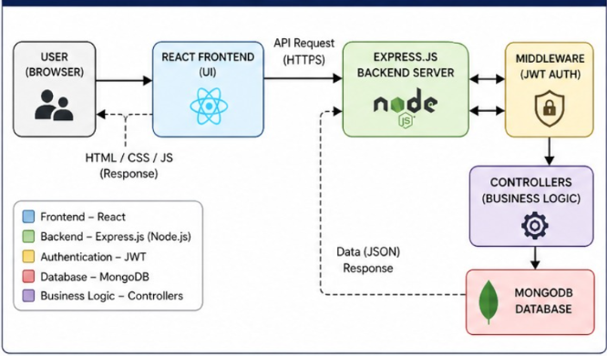
In this architecture, the flow begins with a user interacting with the Train Booking System frontend. The user searches for trains, selects a journey, and places a ticket booking through the frontend interface.
The frontend then sends a request to the Express.js backend server. The backend processes the request, validates the JWT token via middleware, and executes the appropriate business logic.
The backend communicates with MongoDB to store and retrieve data — including user accounts, train details, and booking records. The database persistently stores all submitted data, including seat availability updates and PNR records.
Additionally, the backend handles seat deduction and restoration logic automatically whenever a booking is confirmed or cancelled. Once processed, the backend sends a response back to the React frontend, which displays the result to the user through real-time toast notifications and dynamic UI updates.

ER DIAGRAM:
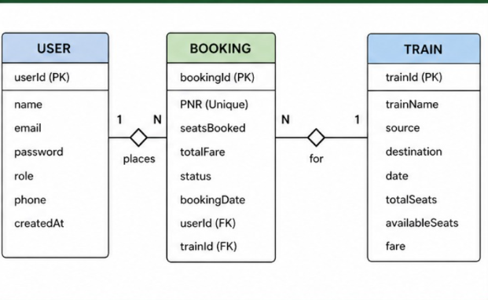
The Entity-Relationship (ER) diagram for the Train Booking System represents the various entities and their relationships within the ticket management system. Here is a description of the key components of the ER diagram:
1. Entities:
- User: Represents registered users of the platform, with attributes such as user ID, name, email, password (hashed), and role (user/admin).
- Train: Represents available trains in the system, with attributes such as train ID, train name, source, destination, date, total seats, available seats, and fare.
- Booking: Represents tickets booked by users, with attributes such as booking ID, PNR, seats booked, total fare, booking status, and booking date.
- 2. Relationships:
- User – Booking: A user can place multiple bookings. Each booking is associated with exactly one user.
- Train – Booking: A train can have multiple bookings. Each booking references one specific train.
- Admin – Train: An admin can add multiple trains to the system.
3. Attributes: Each entity has its own set of attributes that describe its properties. For example, the Train entity has attributes such as train ID, name, source, destination, fare, and available seats.
4. Primary Keys: Each entity has a primary key that uniquely identifies each record. For example, the Booking entity's primary key is the Booking ID, and each booking also carries a unique 10-character PNR.
5. Foreign Keys: Foreign keys are used to establish relationships between entities. For example, the Booking entity has a foreign key referencing the User ID and Train ID to link bookings to their respective user and train.
Overall, the ER diagram for the Train Booking System provides a visual representation of the database schema, showing how different entities are related and how data flows between them in the ticketing system.
Key Features:
The key features of the Train Booking System include the following. User Registration and Profiles: Allow users to create accounts, set up profiles, and manage their personal information securely.
Train Search System: Enable users to search for available trains based on Source, Destination, and Date, including real-time seat availability and fare details.
Booking Engine: Facilitate seamless ticket booking with automatic seat deduction, unique PNR generation, and permanent booking records saved to the database.
PNR Status Checker: Allow any user — even without logging in — to check their journey details and live ticket status using their PNR number.
Booking Cancellation & Seat Restoration: Enable users to cancel active bookings, which automatically restores the released seats back to the train's available pool.
Admin Dashboard: Provide administrators with role-based access to add new trains and view a global ledger of all bookings placed on the platform.
ROLES AND RESPONSIBILITIES:
User:
- Registration and Account Management: Users are responsible for creating an account, providing accurate personal information, and managing their account details, including profile updates and password security.
- Train Search and Booking: Users can search for available trains based on their preferences, such as source city, destination city, and travel date. They are responsible for selecting the desired train, choosing the number of seats, and completing the booking.
- PNR Tracking: Users can use their unique PNR number to check the real-time status of their ticket at any time, even without being logged in.
- Cancellation: Users have the ability to cancel their active bookings from the "My Bookings" dashboard. They should ensure timely cancellation to allow seats to be restored for other passengers.
- Feedback and Reviews: Users have the responsibility to engage with the platform honestly and provide constructive feedback to help improve the service.
Admin:
- System Management: The admin is responsible for overall management and administration of the Train Booking System. This includes monitoring system performance, ensuring data security and privacy, and managing application settings.
- User Management: The admin is responsible for managing user accounts and can view the complete user list and all bookings placed on the platform.
- Train Management: The admin oversees the addition of new trains to the system, ensuring that route information, seat counts, fare details, and schedules are accurate and up to date.

User Flow:
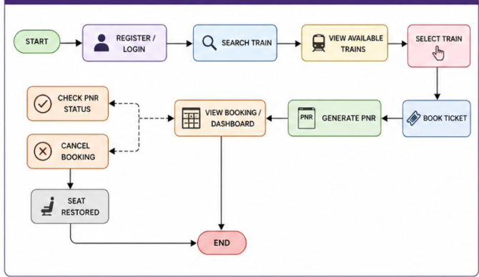
Customer Flow
- Registration & Account – Create and manage account details securely using JWT-based authentication.
- Search & Booking – Search trains by source, destination, and date; select seats and confirm booking.
- PNR Tracking – Use the PNR Status Checker to view real-time ticket and journey status.
- Cancellation – Cancel active bookings from the dashboard; seats are automatically restored.
- Feedback – Leave honest reviews to help improve the platform experience.
Admin Flow
- System Management – Oversee application performance, settings, and security.
- User Management – View, monitor, and manage registered user accounts.
- Train Management – Add new trains with complete route and seat information.
MVC PATTERN:
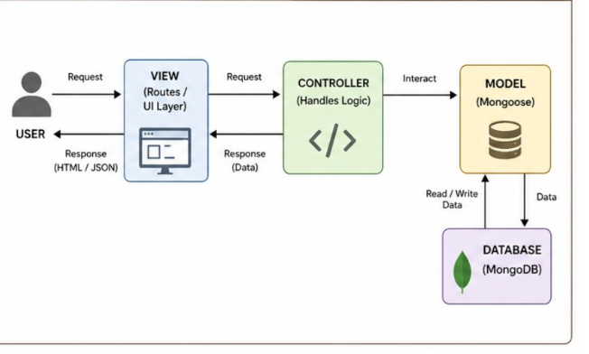
The Train Booking System application follows the Model-View-Controller (MVC) architectural pattern, a software design approach that separates an application into three interconnected layers. This separation allows for modularity, easier maintenance, and scalability.
Model Layer (Data Layer)
The Model layer is responsible for handling all data-related logic. This includes the definition of data schemas and the operations performed on the database using those schemas. The models are implemented using Mongoose, which provides a schema-based solution to model application data for MongoDB. The key models in this project are User.js, Train.js, and Booking.js.
Controller Layer
The Controller layer acts as an intermediary between the view (routes) and the model. It receives incoming requests, processes the input (which may include validation or transformation), calls the appropriate methods from the model, and then returns a response to the client. Key controllers include authController.js (for login/register), trainController.js (for search), and bookingController.js (for booking, PNR, and cancellation).
View Layer (Routing Layer)
In the context of a backend REST API, the View is implemented as the routing layer, where various endpoints are defined. These endpoints determine how the backend responds to different HTTP requests (GET, POST, PUT, DELETE) and are responsible for invoking the appropriate controller functions.
Advantages of Using MVC in This Project
- Separation of Concerns: Each layer has a clearly defined responsibility, improving readability and maintainability.
- Scalability: New features can be added easily by creating new routes, controllers, and models.
- Reusability: Logic in controllers and models can be reused across multiple parts of the application.
- Testing: Each layer can be tested independently, especially the controllers and models.
- Collaboration-Friendly: Multiple developers can work simultaneously on different layers without conflict.
Project Setup And Configuration:
Creating project folder
- Create a new folder with your project name (e.g., train-booking-system).
- Inside that folder, create two new folders.
- Name one as client.
- Name another one as server.
- Now open that folder in VS Code. (photo)
Client setup (installing React app)
- Open the Client folder in the terminal of VS Code.
  - npm create vite@latest . -- --template react
- Select React framework from the given options.
  - Select a framework: React
- Select JavaScript variant from the given options.
  - Select a variant: JavaScript
- Navigate to the client folder:
  - cd client
- To install all packages:
  - npm install
- To start the React server:
  - npm run dev
Server setup (npm init)
- Open Server folder in terminal of VS Code.
  - npm init -y
- Create files:
  - index.js
- Create folders:
  - models
  - controllers
  - routes
  - middleware
  - database
BACKEND DEVELOPMENT:
Backend Reference video: https://drive.google.com/file/d/180ikqLGdAPUxIgz-k5VCCiLtjgAVMGj9/view?usp=drivesdk
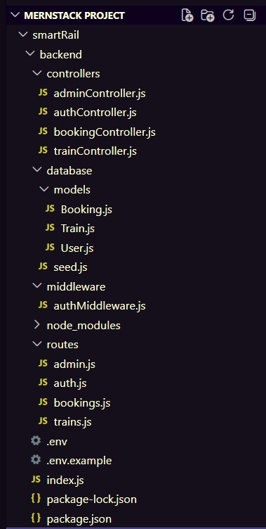
Backend Structure:

Controllers
- authController.js → Handles user registration, login, and JWT token generation.
- trainController.js → Handles train search operations based on source, destination, and date.
- bookingController.js → Handles the core booking engine — seat validation, seat deduction, PNR generation, booking confirmation, cancellation, and seat restoration.
db
- config.js → Contains the MongoDB database connection setup using Mongoose and environment variables from .env.
middleware
- authMiddleware.js → Middleware for authentication and authorization. Intercepts protected routes and validates the JWT token before allowing access to booking or admin features.
models
- User.js → Schema/model for registered user accounts (name, email, hashed password, role).
- Train.js → Schema/model for train records (train name, source, destination, date, total seats, available seats, fare).
- Booking.js → Schema/model for ticket bookings (PNR, user reference, train reference, seats booked, total fare, status, booking date).

routes
- authRoutes.js → Defines API routes for user authentication (POST /api/auth/register, POST /api/auth/login).
- trainRoutes.js → Defines API routes for train operations (GET /api/trains/search, POST /api/trains/add).
- bookingRoutes.js → Defines API routes for booking operations (POST /api/bookings/book, GET /api/bookings/my, PUT /api/bookings/cancel/:id, GET /api/bookings/pnr/:pnr).
DATABASE DEVELOPMENT:
1. Configure MongoDB:
- Install Mongoose. In your Node.js project directory, run: npm install mongoose
- Create database connection.
- Create Schemas & Models.
Create Database connection: (photo)
Make sure the database is connected before performing any actions through the backend. The connection is established using Mongoose with the MongoDB URI stored in the .env file. The connectDB function is called in index.js before starting the Express server.
Create Schemas:
Firstly, configure the Schemas for the MongoDB database to store data in a structured pattern. Use the data from the ER diagrams to create the schemas. The key schemas for this application are:
- User.js → Schema/model for user accounts (name, email, password, role).
- Train.js → Schema/model for train details (trainName, source, destination, date, totalSeats, availableSeats, fare).
- Booking.js → Schema/model for storing ticket bookings (PNR, userId, trainId, seatsBooked, totalFare, status, bookingDate).

FRONT-END DEVELOPMENT:
Frontend Reference video:
https://drive.google.com/file/d/1cFyPwEUb6zXLh_16IsEcFUrnx2kN8etr/view?usp=drivesdk

Frontend Structure:
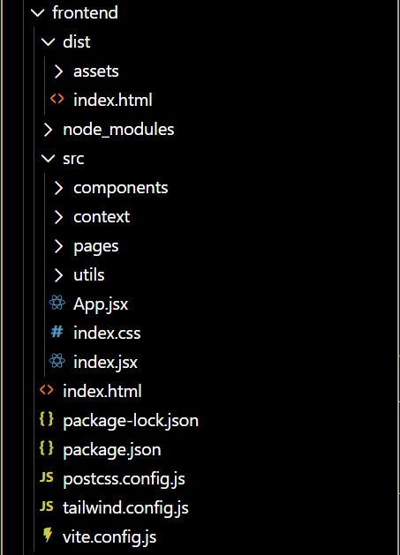

Pages (src/pages)
- Home.jsx → Landing page of the application with navigation options for login and search.
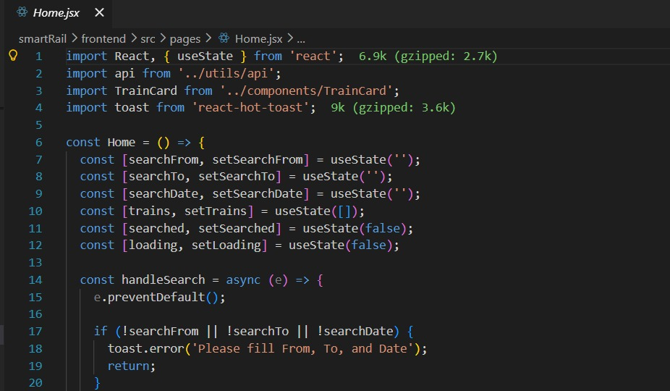
- BookTicket.jsx → Train search page where users input source, destination, and date to find trains.

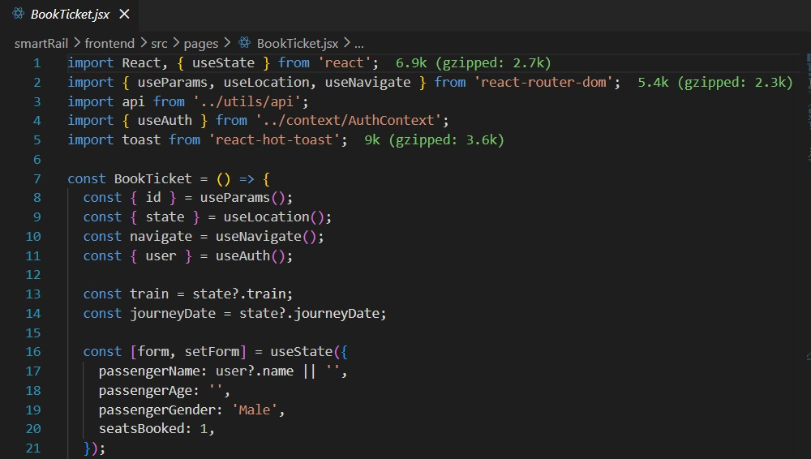
- PNRStatus.jsx → Public PNR checker page where any user can enter a PNR to view ticket status.
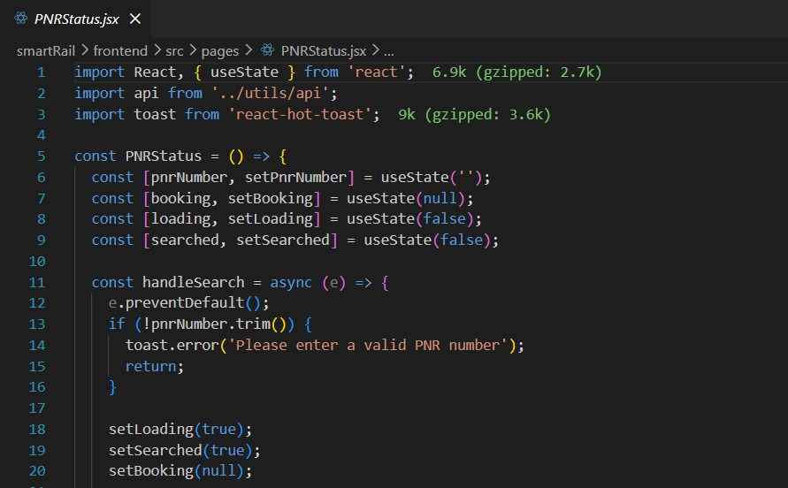
- MyBookings.jsx → Authenticated user dashboard showing all active and past bookings with cancel option.
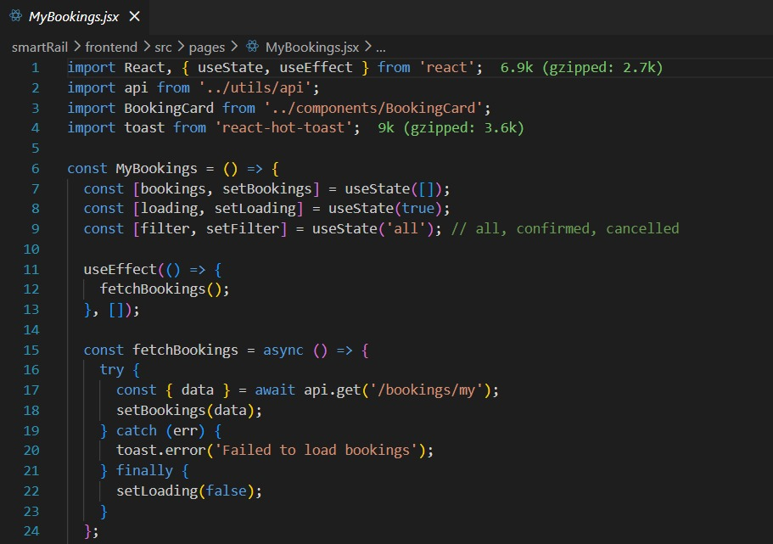
Components (src/components)
- Navbar.jsx → Navigation bar displayed across all pages with role-based menu items.
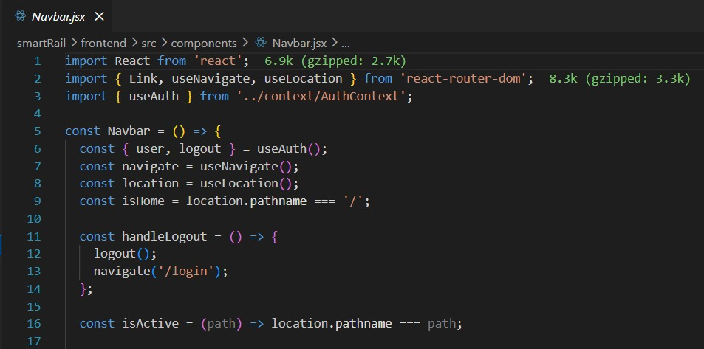
- TrainCard.jsx → Reusable component to display an individual train's details and book button.
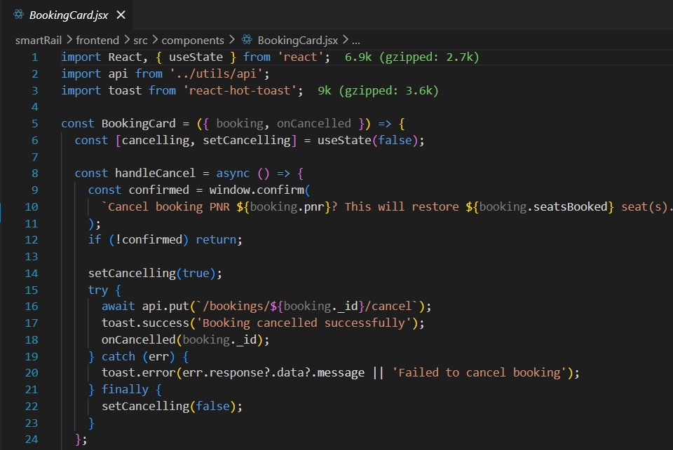
- BookingCard.jsx → Styled component that displays a booking like a real train ticket with perforated edges and barcode design.

Admin (src/pages/Admin)
- AdminDashboard.jsx → Admin homepage showing all platform bookings and a form to add new trains.
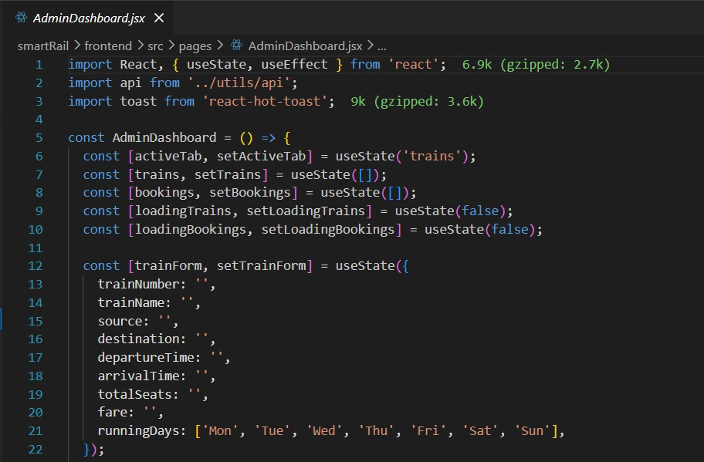
Context (src/context)
- AuthContext.jsx → Global state manager that tracks whether a user is logged in, stores the JWT token, and exposes the user role across all components.

Output ScreenShots:
Home.jsx
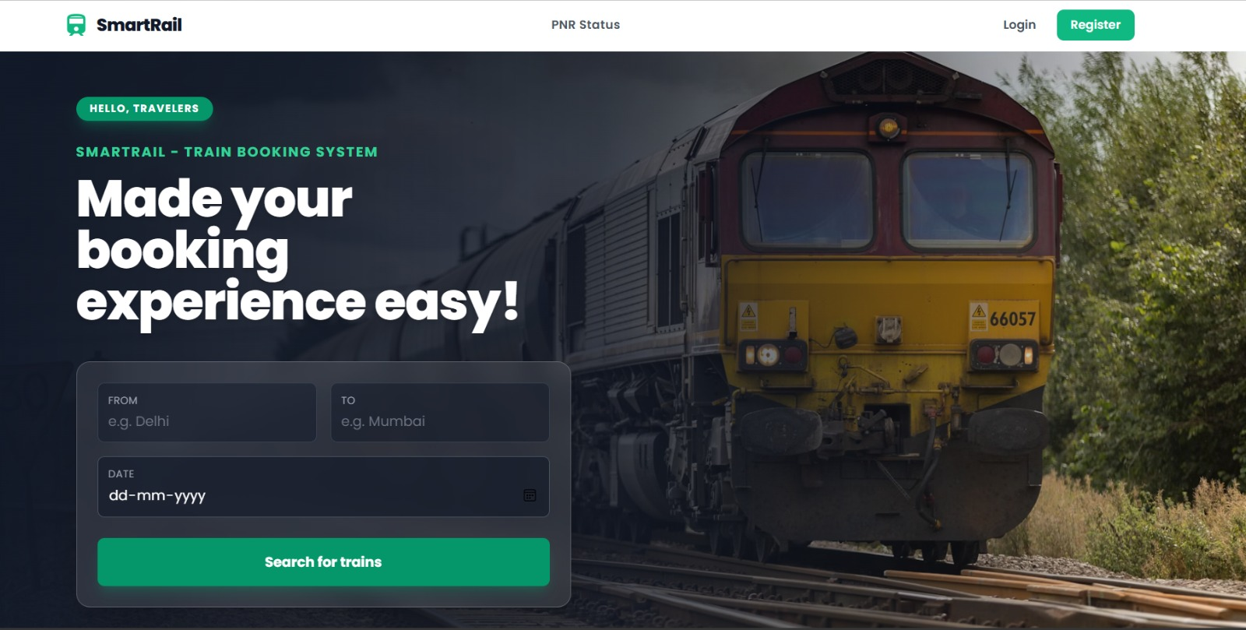
Login.jsx
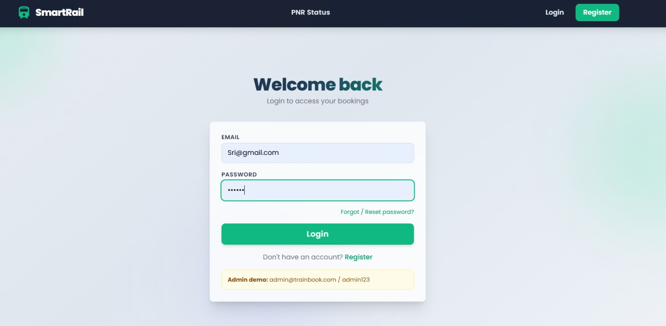
PNRStatus.jsx

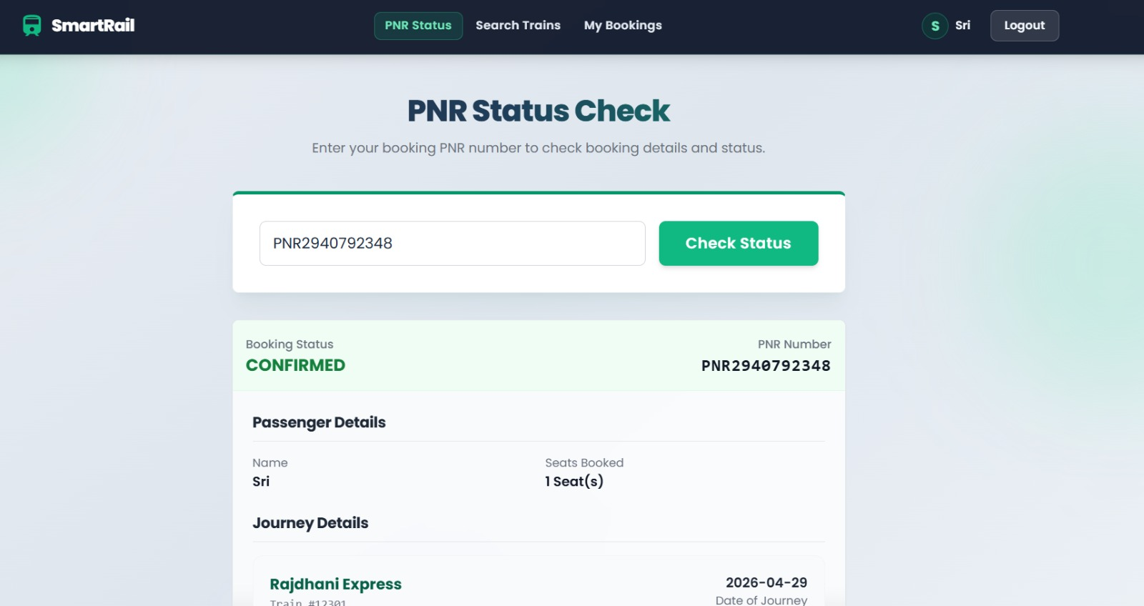

SearchTrain.jsx

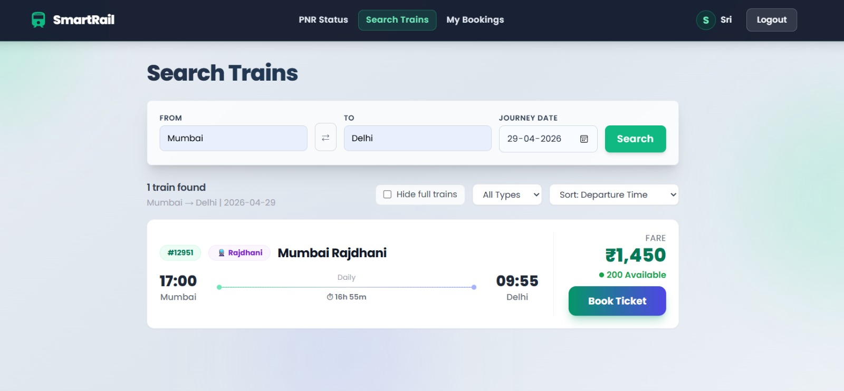
MyBooking.jsx
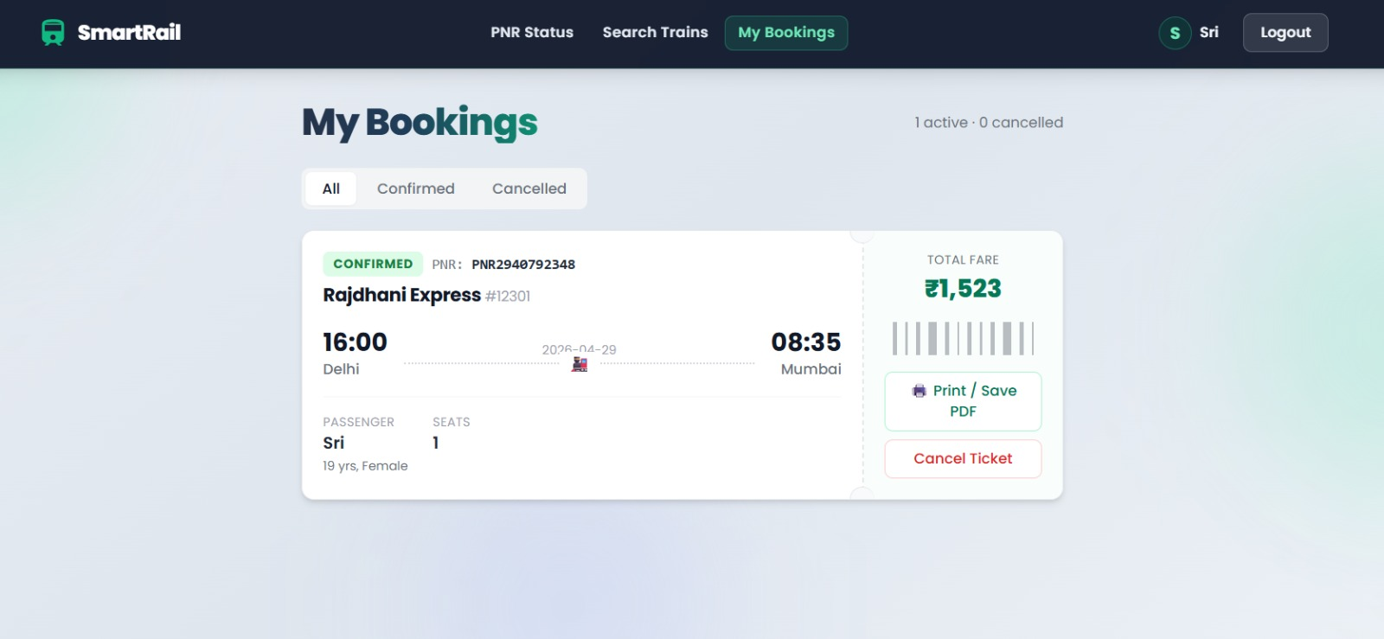

Register.jsx
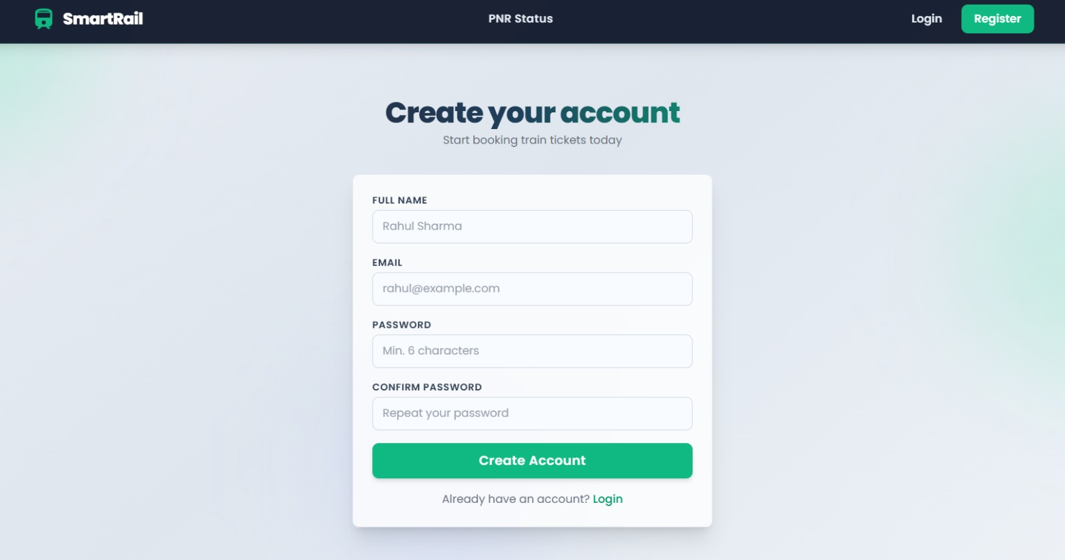

AdminDashboard.jsx
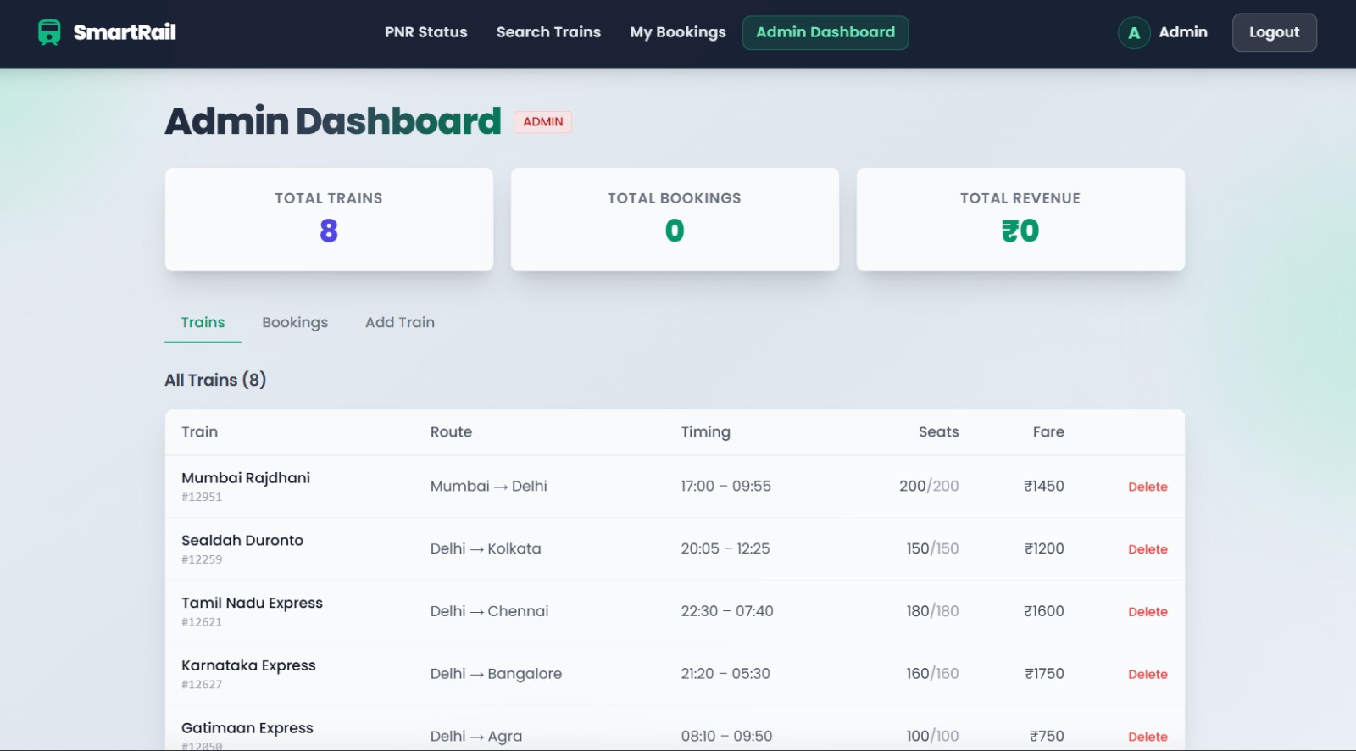

Demo Video Link: https://drive.google.com/file/d/1kuClrHihX81gTz_uYw8FBm-Vg6u_uoum/view?usp=drivesdk

